Table 1: Discharge Calculations
To complete this worksheet, see the instructions in the textbook (Chapter 16 Investigation)
Profile
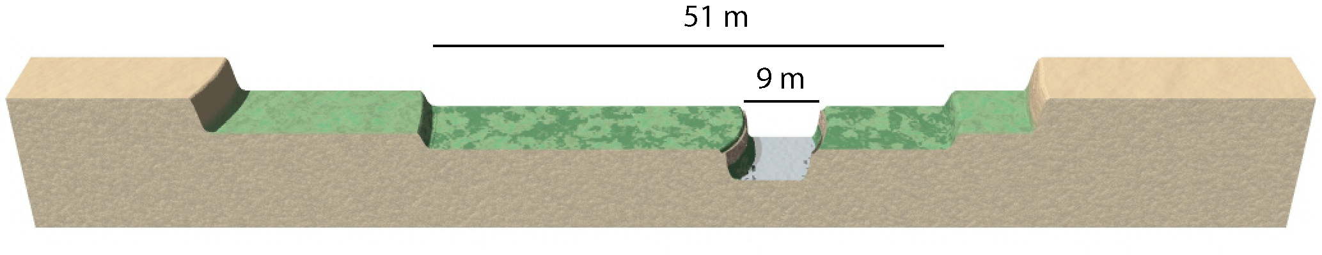
Event | Width  (m) | Depth  (m) | Velocity  (m/sec) | Calculated Discharge  m³/sec
Fill the notch and flood the bottomland | 9 m | 5 m | 0.7 m/sec
Additional needed to flood middle terrace | 51 m | 3 m | 2.0 m/sec
Total needed to flood middle terrace | Add discharges from above

Table 2. Discharge Data and Plot
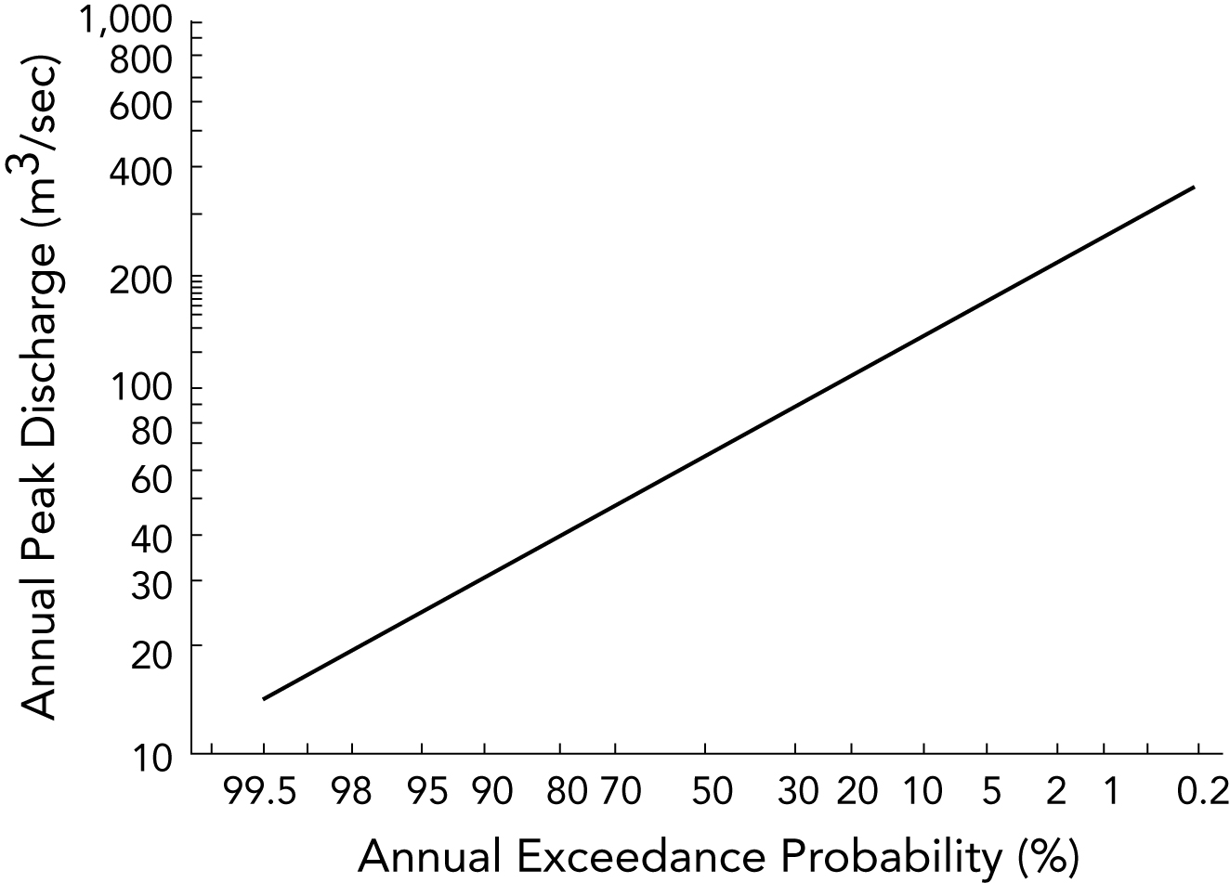
Plot your calculated discharge results on this plot. First find the position of that discharge on the vertical axis of the plot. Draw a horizontal line from that value to the right until you intersect the probability line (which slopes from lower left to upper right). From the point of intersection, draw a vertical line down to the horizontal axis of the plot and read off the corresponding chance of exceedance (probability of flooding) on the horizontal axis. The chance of exceedance indicates the probability of that amount of discharge being exceeded in any given year. Read off the probability associated with each discharge and enter it below.

Probability to Fill Notch: | Probability to Flood Middle Terrace:

Table 3. 3D Perspective of River
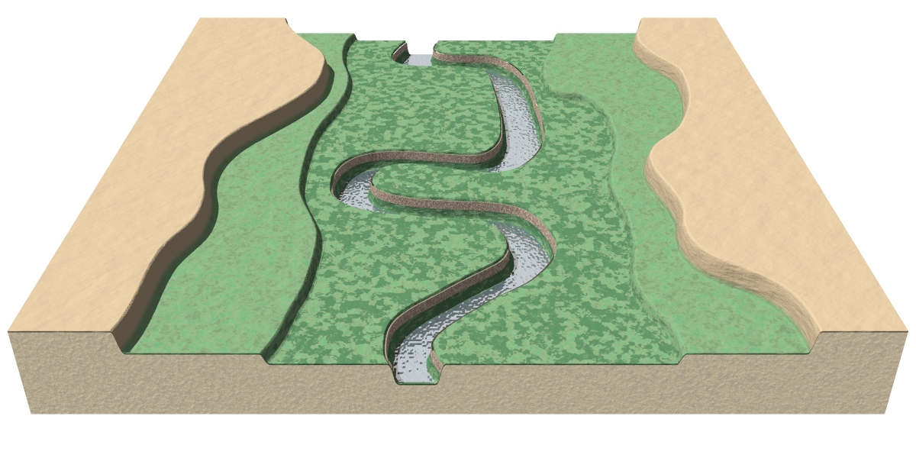
On the figure above, draw your proposed locations for agricultural fields (draw a small square) and five possible homesites for a house (use a simple house symbol). After completing your discharge calculations, rank the five homesites in order of your final preferences, with 1 being your top choice.

Table 4. Explanations for Why You Chose Your Locations
Agricultural fields:
Homesites:
Briefly describe how the probability results affected your ranking of homesites:

